07.04 Production Plan Preparation
Process Design & AMOS Configuration Document
Purpose
This Process Design document is provided to Key-Users to record their key decisions regarding the AMOS Process design and the required AMOS configuration.
It is updated throughout the Project Definition Phase and used as the baseline for the Final Acceptance prior to Go-Live
Revision
Author, Name | Date | Notes
FREL | 12/06/2024 | Initial version
DEOS | 13/12/2024 | Update V24.12
DEOS | 24/07/2025 | Update V25.6

Table of Contents
1. Process Overview & Objectives 3
2. Regulatory References 3
3. Definitions & Glossary 3
4. Process Tasks 4
5. Process Dependencies 4
6. Process Flow 5
7. Process Design Questions 6
8. Data (Source) Mapping 7
9. Other Software Used 7
10. AMOS Configuration 7
a. Basic Data 7
b. Parameters 7
c. Workflows 8
d. Scheduled Tasks 8
e. API’s & Interfaces 8
11. Annex – Additional Info 9
a. Production Planning Configuration 9
b. Production Planning Templates 9
c. Production Planning 10
d. Production Control 10
e. Data display 11
f. Auto Generation by Groups 11

Process Overview & Objectives

Process General Description:
The Production Planning process / functionalities will give the customer the possibility to do a very detailed planning of all maintenance events inside a Workpackage. Standard line maintenance workpackages (up to nights top) are normally easy to handle due to the short timeframe and simple content which have to be performed. As soon as a Workpackage grows and exceed the duration of a night stop, or several shifts it’s required to do a more detailed planning to manage all the resources like
- Staff
- Parts
- Facility
- Tooling
To manage this functionalities by the different user, three different modules are available in AMOS:
- APN 3166 - Production Planning Configuration
- APN 1110 - Production Planning
- APN 1015 - Production Planning Template
- APN 1016 - Production Control

Main Process Objective (Outputs & Outcomes):
The main goal is to give the different user roles an easy overview over a complex Workpackage with a lot of maintenance events, dependencies, and requirements. The overview will be created by a Gantt-chart. The second main goal is that all the request dates are related to the real planning date/time inside this production plan and not to the starting date/time of the Workpackage. This will allow to manage all resources in detail.

Regulatory References

The following regulatory references linked to this process were identified:
- EASA Part-145 145.A.47 – Production Planning

Definitions & Glossary

Key-Words | Explanation
Production Plan | A production plan is a Gantt-chart which is a detailed plan of the planned layover and reflects all maintenance events (like Workorders, Task Cards, etc.) and their dependencies.
Production Plan Template | To reduce the effort, templates can be defined for repetitive production plan times with similar. These templates can be used to auto generate the production plan for a specific Workpackages.
Scope | A Scope is a resource that can be quantified in Estimated Manhours, necessary to execute the work.  Example: To perform a certain work, staff is required that can perform electrician- and mechanical work. The resource planning would indicate that a scope of ELECT* and MECH* with a certain number of manhours is required.  To be defined in APN 18 - Basic-Data Administration - Planning Qualification.

Process Tasks

Main Process Task / Actions / Activities:
The following actions are performed in this Business Process:
- Production Planning Configuration: In this step the production planning key user defined the stagger function and how to handled conflict in the production planner. This step is mainly done once at the setup stage and can be skipped when no adjustment is required. Please refer to the chapter 11.a for more details on this process.
- Create production planning: Once the workpackage scope is defined, the production planning can be created by the production planner. Please refer to the chapter 11.c & 11.f for more details on this process.
- Autogenerate plan (optional): This option allows the user to automatically generate a production plan by grouping the events or steps into a various combination of groups. The most used one is usually Phases and Area. Users can also stagger items depending on the rules established in the first step. Production plan templates previously saved and activated can also be called from that step.
- Edit / modify production planning: Any production plan that is not published to production can be generated/edited by the production planner to fit the needs and capacity of the production team. The planner may use the autogenerate feature to populate the production plan automatically and then adjust it. Conflicts shall also be reviewed at this stage.
- Create Groups & Finding Groups: if not already done in the previous plan or steps, the user can manually add groups subgroups, and finding groups. Finding groups will be used to collect findings when they arise in the check.
- Assign items to the plan: If not auto assigned, or if the items are new, they may require to be assigned to the existing plan. This can be done either manually (drag & drop, or assign to…) or automatically (Auto-assign).
- Edit/Modify the plan: if the current plan does not fit the MRO then it can be manually adjusted or modified.
- Publish to production: Once the plan has reached an acceptable state, it may be published to production. Please refer to the chapter 11.c for more details on this process.
- Production planning template saving (optional): As an additional optional step, the production planner can save the production plan created to be able to re-use for further similar inputs.

Process Dependencies

The following process dependencies were identified for this process:
- 03.02 – Work Package Generation: The work templates will feed information to the system when generating work packages
- 07.03 – Work Templates: The revision of work templates may be required in case of conflicts or when events or steps are missing information.
- 07.04 – Production Planning Preparation: The resource requests, breakdowns and durations defined in the Work Templates will serve as inputs for the production planning preparation and capacity planning functions.
- 07.06 – Customer MRO Workpackages: The work templates will feed information to the system when generating customer work packages
- 08.01 – Maintenance Check Control: The production plan is executed and monitored in this process.

Process Flow
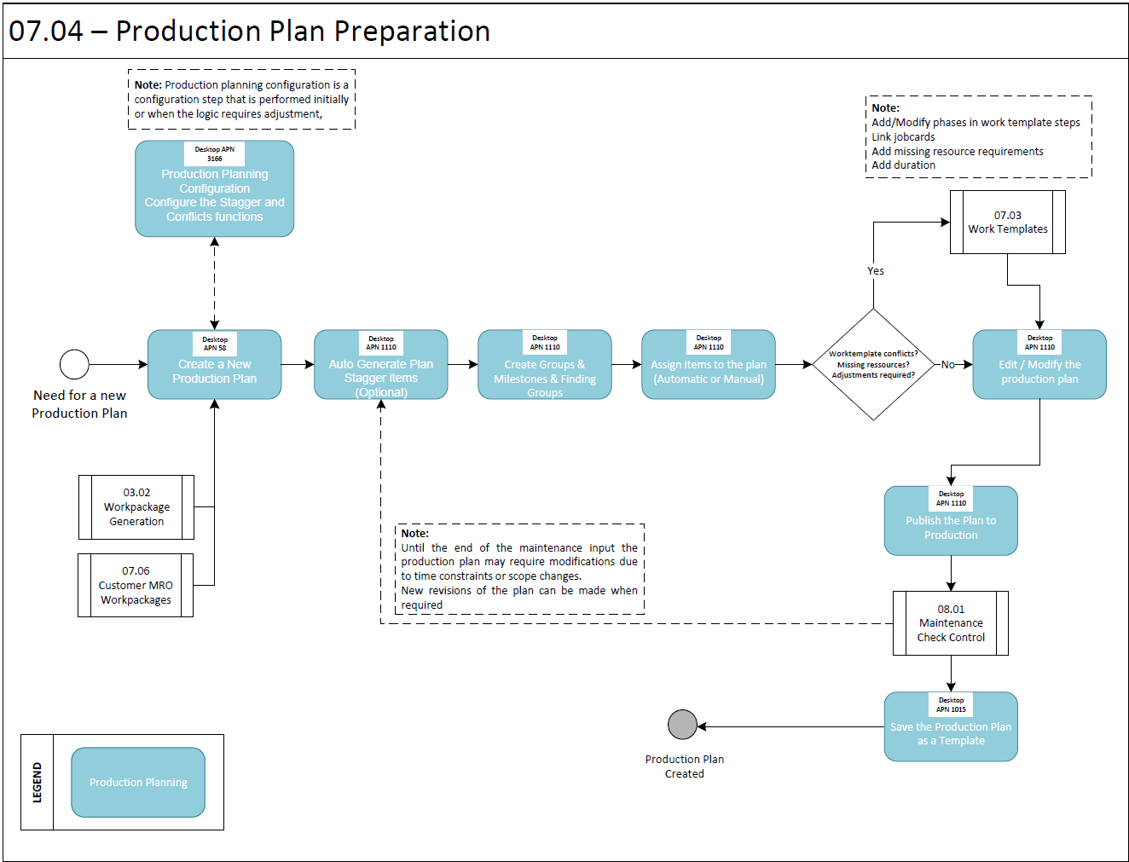

Process Design Questions

# | Question | Answer
1 | How do you plan production plans / layovers now?
2 | Do you have Workpackages with a duration over one shift?
3 | Who (personal/ department) is responsible for creating production plans?
4 | How do you manage your capacity planning - is line/base capacity planning split or merged?
5 | What is the planning date for your parts (materials / tools) at the moment - are they available from starting of the Workpackages all the time or only for time period when the related maintenance event is planned?
6 | Do you create production plans for all your inputs? What is the yes/no limit in case there is one?
7 | When are production plans updated? Who initiates the request? Who approves/handles it?

Data (Source) Mapping

Data Sources | Description | Volume / Manual / Automatic / Static / Dynamic
XWORKTEMPLATE | Generic Worktemplate Transfer | Title / Number / type
XWORKSTEP | Generic Workstep Transfer | Phase/Step classification  Static Data (e.g., CPCP, Critical task etc…)
XWORKSTEPRESOURCE | Workstep Resource Requests | Estimated Man hours / Qualification

Other Software Used

Other Software | Used by: | Description
-Nil-

AMOS Configuration

Basic Data

Basic Data Table | Notes
Work Step/Phase | To define phases of the check for Production Planning

Parameters

Parameter Code | Parameter Name | Notes
1837 | Early booking hours | To control which time-bookings that were made before the WP start date, are considered in Production Control (APN 1016) for heavy maintenance workPackages.  The string also controls if live time bookings or accomplishments move events around when the replan button is hit in production control APN 1016.

Workflows

Workflow Number | Workflow Name | Notes
-Nil-

Scheduled Tasks

Scheduled Task Reference | Frequency | Notes
-Nil-

API’s & Interfaces

Reference | Direction | Trigger | Frequency
-Nil-

Annex – Additional Info

Production Planning Configuration

Production Planning Configuration is used to configure the Stagger and Conflicts functions in Production Planning

Priority tab
In the Priority tab you can configure what sort of tasks should be scheduled first by the Stagger.
Field | Description
Name | Name of the property entered in the field.  Example : Borescope
Field | Code defined for the task.  Example : BSI [Task Type]
Priority | Priority of the task. The highest priority is 1.
Actions | Use the plus and minus icons to add and remove entries.
Priority of critical events | Enter a priority to be assigned to critical events. The highest priority is 1.  An event is critical when one of its work step has the classification Critical Task.
Priority of other events | Enter a priority to be assigned to other events. The highest priority is 1.  Other means events that are not critical and that do not match any of the properties defined in the table above.
Example:
Borescope with priority 1, Inspection with priority 2, Lubrication with priority 5, Critical Events with priority 3 and Other Events with priority 4.
When you use the Stagger button in Production Planning, it will try to schedule first all tasks with a task type Borescope, then Inspection, then Critical Events, then events matching none of the given criteria, then tasks with Lubrication.

Production Planning Templates
To reduce the effort and workload it's recommended to create production plan templates in APN 1015 for repetitive production plans with similar content. Production plan templates can be created for example for:
- Single Checks (e.g., large base maintenance check)
- Combination of different checks (e.g., A-Check in combination with routine check)
- Single Taskcards from Maintenance Program can be combined / added.
- Single Jobcards / Customer Requirement can be combined / added.
When a check is added to a production plan template, the taskcards must be collected. During this collection also Jobcards which are linked to a taskcard are collected and can be used in production plan template. Jobcards which are linked to a check must be added manually.
Please note, whenever there is a revision of a check (content is changed) or links between taskcards and Jobcards are adjusted this will have no influence on already production plan template. The affected production plan template needs to be revised and recollection of related maintenance event to be done. To do a revision of a production plan template it's required to "Archive Template", create a new template based on old revision by using "Save as New" function. After the revision activation is done by using "Activate Template" the template will be available for further processing in APN 1110 - Production Planning.

Production Planning

When creating a production plan for a specific Workpackage, in first approach all maintenance events of the Workpackage are displayed as "Unassigned" - There are different methods / possibilities to do the assignment / staggering of the items:
- Auto-Generation by using existing production plan template: If a production plan template is already existing, this can be used as a baseline for an automatic assignment / staggering. This is the easiest way to create the biggest part of the production plan. Maintenance event which are not covered by the template will stay "unassigned". Multi selection of different production plan templates are possible.
- Auto-Generation by using criteria / groups: A grouping can be defined in criteria tab sheet. When using this auto-generation method, different groups will be created in the production plan and maintenance events will be assigned to the groups based on the main data inside the maintenance event (e.g., ATA Chapter, Area, Phase, etc.). With this option all maintenance events will be assigned - in case the relevant data is missing in the maintenance event, this event will be assigned to a default group like (No Area, No Phase, etc.)
- Auto-Assignment option: In the case that different groups and criteria are already defined / created, unassigned events can be fully automatically assigned to the matching groups depending on the main data inside the maintenance event.
- Manually: Of course, single maintenance events can be assigned / staggered fully manually inside a production plan. This option should only be used to a single / small number of items to add them to specific position(s) inside a production plan.
- In addition to the planning of all items of the Workpackage, it's recommended to create dedicated finding groups inside the production plan. These finding groups will fulfil following requirements:
- A workload for potential findings will be simulated / created without having any finding workorders in the beginning of the production plan - having this simulated workload will make the capacity planning easier.
- It's possible to configure a group as "default finding group" - whenever a finding is created this will be automatically assigned to this group without a need to revise the production plan. Of course, the man hours which are defined for the group and which are defined on the workorder will not be cumulated. As soon as the threshold man hours of the finding group is reached, the real workload and sum of finding hours of the workorder will be used for capacity planning.
As soon as a production plan is completely planned, the plan could be release to production. From this point no more changes are possible in the APN 1110 and the APN 1016 - Production Control will be used for monitoring the progress / status of the production plan.

Production Control
In APN 1016 the progress and status of the production plan is monitored. It's possible to create snapshots on a specific time and also creating reports for f.e. production meetings, reporting to management, etc.
No changes can be done in Production Control. Whenever a change / revision is required, the production plan can be re-planned in APN 1110 by using "Re-Plan" functionality. Using this button, this will create a new revision of production plan in "planning" status. As soon as revision is finished and plan is released to production in APN 1110 the plan will become active and change the status to "Production" and the old version will be "Archived".

Data display
To get a good overview from perspective of a special user (e.g., shift leader, lead mechanic of a qualification group, etc.) a lot of filter and configuration possibilities are available in Production Control and Production Planning APNs
Filters:
Filters can be set for all planning relevant data, event status and for a specific time frame. With help of this f.e. User can filter only for events which are during his shift and relevant for his team (f.e. depending on qualification).
Filters for planning relevant data are well aligned with the APN 2323 - Resource Planning and APN 58 - View/Edit Workpackage - with help of this it will be very easy to find to correct tasks to do the staff assignment and all things which are related to maintenance event performance and documentation:
Tree Views:
A tree view which is very easy to handle is also available in Production Control. With help of this it is very easy to collapse / expand the list of maintenance events and graphical view. This makes it very flexible for the user because it's possible to show different views on an easy way.
Workload Summary:
The workload summary, which is already available in other application like Workpackage Browser, is also very easy and flexible configurable by end user - F.e. If it's configured to shift length and aligned with starting times of shifts it's very easy to see how many manhours in total or per qualification are required to cover the planned work.
Of course, this can be also used to do a staff / capacity planning for a production plan in the future - already pre-planned production plans can be analysed, and it can be defined how many manhours will be required per day / week / month / etc. to cover the planned event.
Depending on the selection in APN58 - View/Edit Workpackage this workload distribution will be considered for overall staff capacity planning in APN30/711/1024.

Auto Generation by Groups
As well in Production Planning as in production plan template program it is possible to do an automatic generation. The production plan / template will be automatically generated related to group definition. Depending the selection AMOS will check which groups are required (based on the maintenance events), create the groups, and assign maintenance events to matching group. Combination of different groups are possible - for example grouping can be done by phase and qualification.
To get a good overview / transparency groups can be configured easily and individually in colour and title as shown in example. In addition, amount of maintenance events and Mhrs inside is group is displayed.
Please note, that it will be very important to have very detailed / correct planning data on the maintenance events / work templates. Only with a very high quality of this data an automatic generation is possible because the system does the staggering fully automatically based on the planning data.

